1. **What is the total sales revenue generated by each product category in 2017, and how does it compare to the previous years i.e. 2016 and 2015?**
2. I used “Product-Categories”, “Product-Categories”, “Product-Subcategories”, and “Sales-2015/16/17” datasets. To better manipulate the sales data, I merged the “Sales-2015/16/17” into one data query – “Master Sales” to allow for a year-over-year comparison. Relationships are established between the “Master Sales” and “Product-Categories” through the “Products and Product-Subcategories” table.

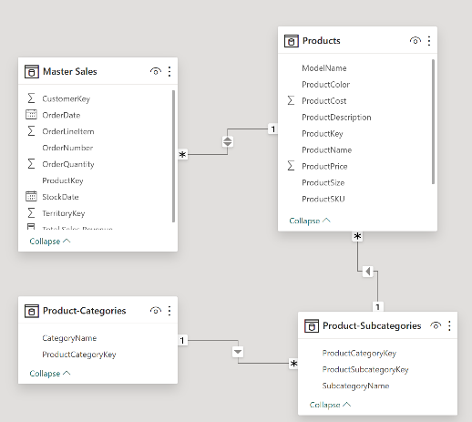

I create DAX measure to calculate sales metrics.

“Total Sales Revenue = SUMX('Master Sales', 'Master Sales'[OrderQuantity] * RELATED('Products'[ProductPrice]))”. I changed the format of “Total Sales Revenue” to currency.

I use the built-in date hierarchies “OrderDate” to extract “Year” to do the comparison.

1. The final visualization is a stacked bar chart with “OrderDate”[Year] on the X-axis, “Total Sales Revenue” on the Y-axis, and “CategoryName” in the Legend. The stacked bar chart was chosen because it provides a clear comparison of total sales revenue across different product categories and allows for a comparison across different years. The stacking shows the proportion of each category's contribution to the total, making it easy to compare not just the total revenue but also the category performance.

(iii) Business stakeholders can use this visualization to identify trends in sales performance over time. They can see which categories are growing or declining and how the mix of product sales changes year over year. This insight can inform future business strategies, such as deciding which product categories to focus on, where to allocate marketing budget, or when to launch new products. It also helps in inventory planning and forecasting demand.

1. **Which territories, product categories and product subcategories have the highest return rates?**
2. I used “Product-Categories”, “Product-Subcategories”, “Returns”, and “Territories” datasets. I created Territories Hierarchy to drill down from continents to countries to regions. Beside the relationships in Q1, I connected Master Sales to Territories, and Returns to Product and Territory.

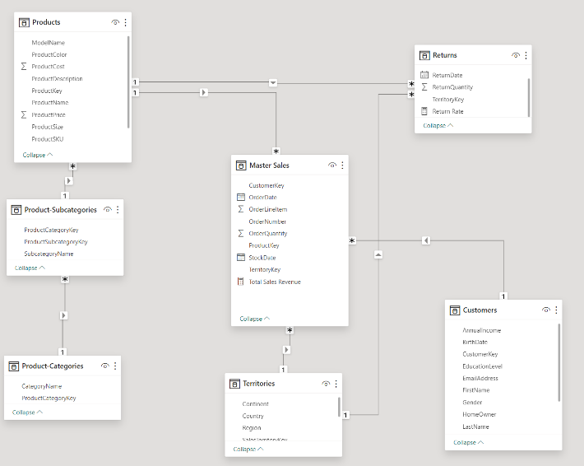

I create DAX measure to calculate return metrics.

“Return Rate = DIVIDE(SUM('Returns'[ReturnQuantity]),SUM('Master Sales'[OrderQuantity]))”. I changed the format of “Return Rate” to percentage.

1. The final visualization is a bar chart with “Territories Hierarchy”, “Category and Sub-category name” on the X-axis, “Return Rate” on the Y-axis, and “Territories Hierarchy” in the Legend. A bar chart is chosen for its straightforward representation of comparative data. It allows stakeholders to quickly discern which territories, categories, and subcategories have the highest return rates through the length of the bars.
2. The visualization enables stakeholders to identify high return rate areas at a glance, which is critical for addressing issues related to product quality and customer satisfaction. By targeting the areas with the highest return rates, businesses can focus their efforts on reducing these rates, which can lead to improved customer satisfaction and reduced costs associated with returns.
3. **What is the customer demographics breakdown by gender, age and education level in 2017 and how does it compare to the previous years i.e. 2016 and 2015?**
4. I used “Master Sales” and “Customers” datasets. The relationship is just between Master Sales and Customers. Extract the year from the OrderDate in the Master Sales dataset to filter transactions by year.

Added a page-level filter to exclude 'NA' values in Gender. Created new column “Age = 2024 - YEAR(Customers[BirthDate])”. I realized the age range is wide, thus make another new column “Age Group”

Age Group =

SWITCH(

TRUE,

Customers[Age] < 18, "<18",

Customers[Age] <= 24, "18-24",

Customers[Age] <= 34, "25-34",

Customers[Age] <= 44, "35-44",

Customers[Age] <= 54, "45-54",

Customers[Age] <= 64, "55-64",

Customers[Age] >= 65, "65+"

)

Which classified customer into different age ranges and enhanced the visualization.

1. The final visualization is a clustered bar chart with “Gender”, “Age Group” and “Educational Level” on the X-axis and Count of “CustomerKey” on the Y-axis, and add Year as a legend to compare across different years. Clustered bar charts are chosen for their ability to compare multiple categories across different series (years) clearly and concisely. This allows for quick comparison across demographics and time.
2. Business stakeholders can use the demographic breakdown to identify trends in their customer base over time, such as shifts in the gender ratio or changes in the predominant age group or education level. Comparing demographic data over several years allows businesses to track the effectiveness of their initiatives and adjust their strategies to align with demographic shifts.